The Advice Tree

Requirements Document
Version 1

February 10, 2013

Group members:
Timothy Cao
Taylor Comer
Benjamin Holley
Christian Morrison
Dale Alberts

Group 1

Instructor:
Rikk Anderson

Table of Contents

1. Introduction .......................................................................................................................................................... 4
1.1. Purpose .......................................................................................................................................................... 4
1.2. Definitions, Acronyms, and Abbreviations .....................................................................................................4
1.3. References ..................................................................................................................................................... 5
2. System Overview ................................................................................................................................................. 5
2.1. Purpose ........................................................................................................................................................ 5
2.2. Use Case Diagram ....................................................................................................................................... 5
3. Specific Requirements......................................................................................................................................... 6
3.1 Seek Advice[Category]…………………………………………………………………………………………6
3.1.1 Description
3.1.2 Actors
3.1.3 Steps
Appendix A: User Interface ................................................................................................................................... 10

Appendix B: Initial Task and Role Assignments.................................................................................................... 16

1. Introduction

1.1 Purpose
The purpose of this Requirements Document is to specify the software requirements of The Advice Tree, a site where users share advice with other uses whether it be school or life related. This document will explain and define the concept and all steps of The Advice Tree's development.

The intended audience of this document is the software developers, Mr. Anderson, and the CSE faculty.

1.2 Definitions, Acronyms, and Abbreviations

Post To upload an advice for other users to view.

Advice A string of text that contains a sentence of helpful or useful meaning.

Flagging To mark an advice that is demeaning, hateful, or disrespectful for the Administrators
to remove.

Upvote A method for other users to mark if the specific advice was helpful or meaningful.

Downvote A method for other users to mark if the specific advice was not helpful or meaningful.

1.3 References

2. System Overview

2.1 Purpose
The Advice Tree will be a user intractable site where they will post and interact with advices. The site will display a random advice on the front page for guests to view but not interact with. Users will be able to register and log into the site to create their own advice and interact with other advices. There will be a menu for the current user to post an advice, view their advices, and delete their advices. While viewing an advice of another user, the current user may comment, upvote, downvote, or flag that advice. The Advice Tree will allow the Administrators of the site to manage each individual advice with ease to remove any flagged advice.

2.2 Use Case diagram

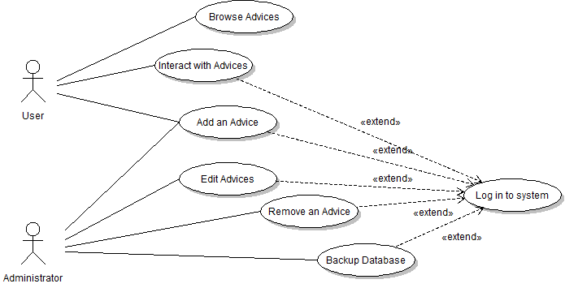

3. Specific Requirments

3.1 Seek Advice[Category](Required)

3.1.1 Description
A member would use this funtion to look for and generate advice of a certain category.

3.1.2 Actors
User

3.1.3 Steps
1. User begins at website main page.
2. Main page displays randomized advice, login panel or member login info panel, and
category panel.
3. Links in the upper right corner allow the user to define advice by category e.g.
Lifestyle, Grooming, Cooking, School, Relationship.
4. User redirected to category main page where a random piece of categorized advice is
displayed.
5. Category main page contains login panel/member info, random advice, and category
panel.
6. User can use a randomize button to generate additional advice in selected category.

3.2. Add Advice[User] (Required)

3.2.1. Description
A user would use this functionality to add advice to the site’s collection of advice.

3.2.2. Actors
User

3.2.3. Steps

- The user starts at the home page of the site and must login using the data fields on the side of
the page.

- The site will go to a page similar to the home page, except the spot where the login data fields
were on the previous page are replaced with a message welcoming the user back, a message notifying them of any comments that have been made in response to your previously added advice, an “Add an Advice” link, and a “Manage you Advices” link.

3. The user will click the “Add an Advice” link.

- The site goes to a page containing a data field where they can type the piece of advice, a
dropdown menu where they can select the category this advice is to be put under, and a button for completing the process of adding a piece of advice to the site.

- The user will enter a piece of advice into the advice field, choose a category from the
dropdown menu, and click the complete button to finish adding the advice to the site.

